README - Configuring MTCService4OPC

To install the MTCService4OPC on a remote machine:
=================================================

1) Setup MTC Agent configuration found in the file "MTCService4Opc.exe.config" You can program multiple devices on multiple machines.

You will need to configure these items: (for OPC server on 192.168.4.11 & Mazak1 device).
<add key="devices" value="Mazak1" />
<add key="ipaddrs" value="192.168.4.11" />
<add key="Debug" value="0" />

For 2 devices:
<add key="devices" value="Mazak1,Mazak2" />
<add key="ipaddrs" value="192.168.4.11,192.168.4.12" />
<add key="Debug" value="0" />

Currently is configures for Siemens 840D OPC server data acquisition, but could easily be modified in the .config file for other OPC servers. For now, all MTConnect backend devices must use the same OPC server id.

Please scan the Devices.xml file to make sure there is a heartbeat tag contained in it.

2) Move to C:\MTConnect4OPC folder (or wherever you extracted the zip contents - shouldn't matter.)

RUN: installservice.vbs
RUN: configure.bat

This automatically installs the "MTConnect4OPCService" into the Microsoft Service Control Manager (SCM) as automatic service with error recovery. You can confirm this in the Windows SCM.

3) Start MTConnect4OPCService

RUN: startservice.bat

Better, you can go into the Windows Service control manager and manually start the process.
MyComputer->Right Click (Select Manage) -> Services and Applications -> Services -> "MTConnect4OPCService" -> Right Click (Start)

This way you can see if it started.

4) See if agent is getting data.

RUN: MTConnectPage.vbs

will pop open an internet explorer web page with MTConnect data and update every 3 seconds..

or manually enter into Internet Explorer ]

http://127.0.0.1/current/

and you should see a web page of XML.
Fri 01/22/10 04:17:10 PM

WTF
Runs as a service: SYSTEM must be allows remote launch and activation permissions.
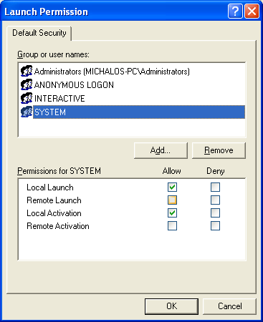

When I tried to run the service as SYSTEM. STILL DIDN’T WORK!!!!!!!!!!

Instead I had run the service as an authenticated account.
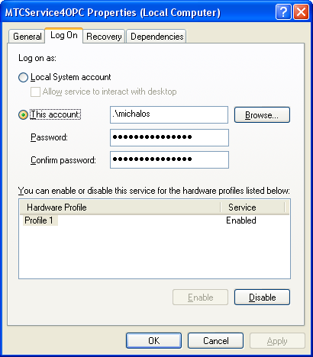

WTF

